From Surviving to Thriving: Building Leadership Structures to Support Employee Well-being​

Partner Spotlight: Julie Oehlert (CXO), Mark Dunn (CDIO), and Christina Bowen (CWO) from ECU Health
- At ECU Health, well-being is the mission for team members, patients, and eastern North Carolina.
- The leadership team developed a “mosh pit mentality” to support well-being, where all senior leaders own and support well-being. This includes the Chief Human Resource Officer, Chief Medical Officer, Chief Quality Officer, Chief Experience Officer, Chief Diversity and Inclusion Officer and a new Chief Well-Being Officer who reports through both the CXO and CDIO.

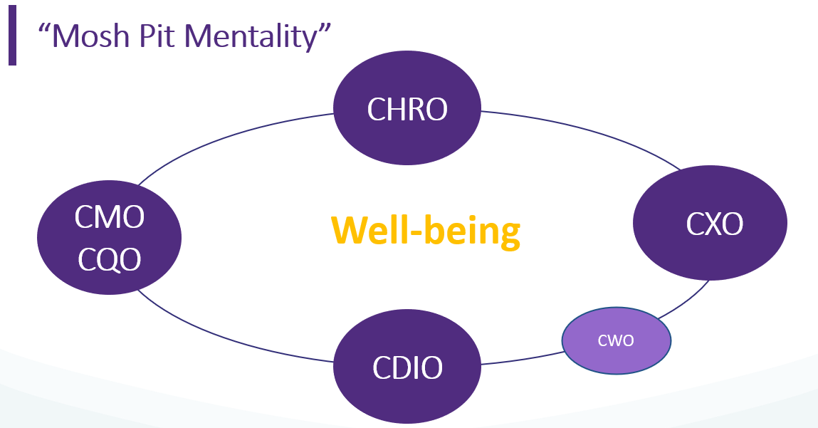

- ECU Health refers to experience as the “Big E”. They use a quadruple aim to optimize health system performance and support the “Big E”:
  - Creating exceptional care experiences.
  - Improving the health of people and communities.
  - Making care more affordable.
  - Enhancing team member well-being.
- The Culture Transformation Theory is at the heart of the “Big E” strategy - everyone’s experience matters, and how employees experience each other is how patients experience us. The goal is to create a “Power With” culture, built on safety, trust, compassion and empathy.
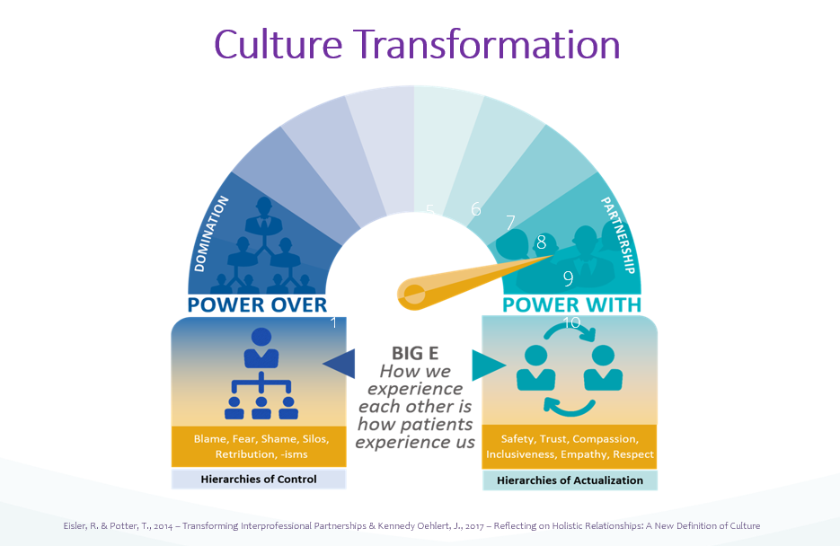

- ECU Health uses Press Ganey’s Resilience Index to measure well-being. This index consists of 2 subscales:
  - Decompression = the ability to disconnect from work
  - Activation = the degree to which individuals connect to the meaning of their work
- Why should we take time to decompress?
  - We are all human beings not machines.
  - Our body, mind and spirit need rest.
  - Decompression supports our emotional well-being.
  - Our brains need down time to process our day.
  - We want to be present for our lives and for those we love and serve.
- We can’t talk about Self-Care without first mentioning resilience. For some, the word “resilient” doesn’t feel right. Maybe the word for you is “thriving” or “flourishing”.
  - Our ability to bounce back, thrive or flourish is enhanced when we care for ourselves.
  - When we are in this state of resilience, we are more likely to focus and prioritize self-care.
- Prioritizing a healthy life-work balance is the foundation of Self-Care. This self-care will look different for everyone and can be as simple as taking a step back, spending time alone, putting yourself first, asking for help when you need it, setting boundaries, staying at home, saying no, or forgiving yourself.
- When leaders practice life-work balance that heavily relies on self-care and healthy boundaries, this models those behaviors for team members who will be watching and will follow your lead.
  - With this gentle shift in your leadership philosophy and practices, it will become a part of the culture.
- Self-care can also be encouraged at all dimensions of employee well-being:
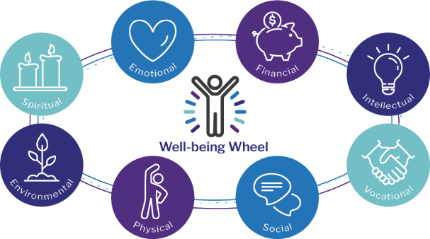

Ask yourself: How will you support your team’s well-being?

- Additional ECU Health resources and publications:
- Themes in Health Care Culture: Application of Cultural Transformation Theory
- What’s Love Got to Do With It?

Resources
Webinar Recording | Link to Resource
Presentation Deck | Link to Resource

